Tutorial – 1

1 : Write a program to print “Hello World”.

using System;
using System.Collections.Generic;
using System.Linq;
using System.Text;
using System.Threading.Tasks;

namespace Tutorial__1
{
internal class Hello
{
static void Main(string[] args)
{
Console.WriteLine("Hello, World!");
}
}
}

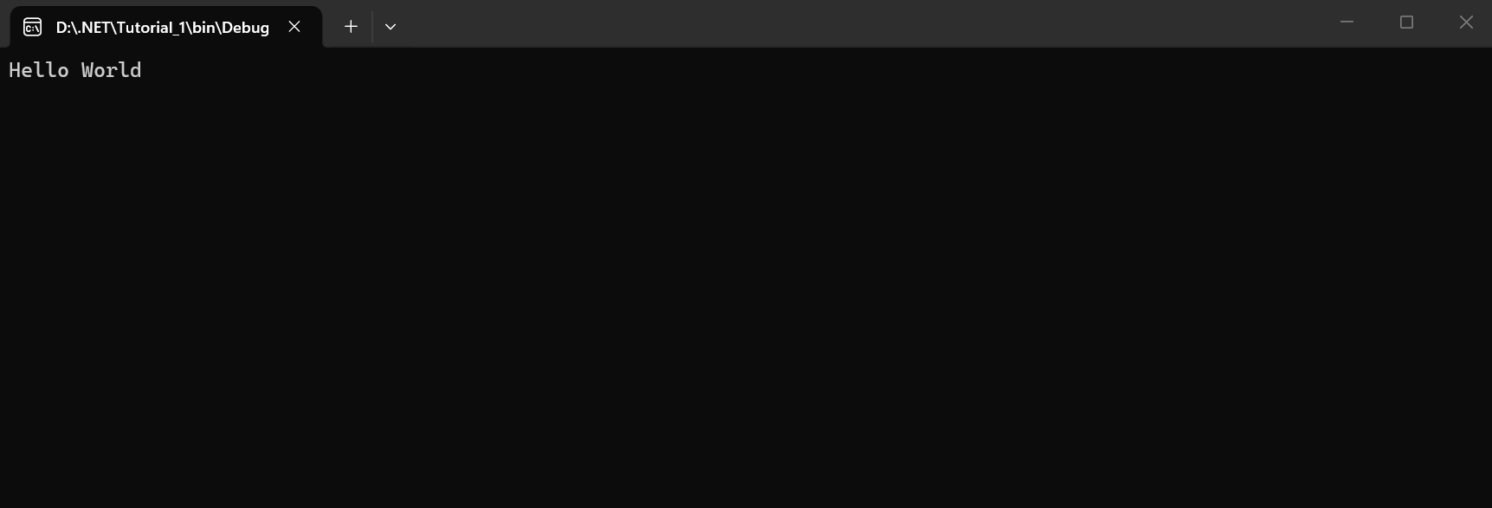

2 : Design your profile page as given below.
$$
Name: your name
DOB: 15/10/1991
Address: 4, xyx society,
Kalawad Road
City: Rajkot
Pincode: 360 001
State: Gujarat
Country: India
Email: abc@ymail.com

using System;
using System.Collections.Generic;
using System.Linq;
using System.Text;
using System.Threading.Tasks;

namespace Tutorial__1
{
internal class About
{
static void Main(string[] args)
{

Console.WriteLine("Name: Lunagariya Rajvi");
Console.WriteLine("dob : 04/04/2007");
Console.WriteLine("Address : jamna park -3 , morbiroad , rajkot");
Console.WriteLine("City : Rajkot");
Console.WriteLine("Pin code : 360003");
Console.WriteLine("Country : India");
Console.WriteLine("State : gujrat");
Console.WriteLine("Email : rlunagariya447@gmail.com");
}
}
}

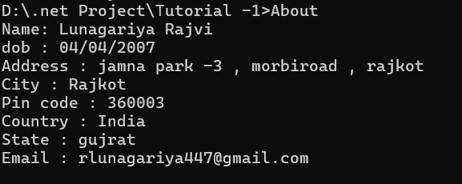

3: Find out whether the given number is odd or even.

using System;
using System.Collections.Generic;
using System.Linq;
using System.Text;
using System.Threading.Tasks;

namespace Tutorial__1
{
internal class EVEN_ODD
{
static void Main(string[] args)
{
int number;
Console.WriteLine("Enter a number: ");
number = Convert.ToInt32(Console.ReadLine());
if (number % 2 == 0)
{
Console.WriteLine(number + " is an even number.");
}
else
{
Console.WriteLine(number + " is an odd number.");
}
}
}
}

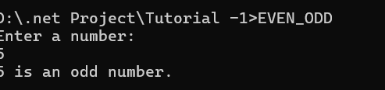

4 : Rearrange the given code to correct the program. The resultant program will be to input a number and print whether the given number is odd or even.

namespace ConsoleApplication1
{
{
static void Main(string[] args)
{
int x;
Console.WriteLine("Enter Number : ");
x = Convert.ToInt32(str);
Console.WriteLine("Number is Even");
else
Console.Read();
string str = Console.ReadLine();
if (x % 2 == 0)
Console.WriteLine("Number is Odd");
}
}
}
class Program
using System;

Output:
Enter Number: 10
Number is Even

using System;
using System.Collections.Generic;
using System.Linq;
using System.Text;
using System.Threading.Tasks;

namespace Tutorial__1
{
internal class EVEN_ODD
{
static void Main(string[] args)
{
int number;
Console.WriteLine("Enter a number: ");
number = Convert.ToInt32(Console.ReadLine());
if (number % 2 == 0)
{
Console.WriteLine(number + " is an even number.");
}
else
{
Console.WriteLine(number + " is an odd number.");
}
}
}
}

5 : Write output of the program. Also write comment for each line for the following code.
using System;
namespace ConsoleApplication1
{
class Program
{
static void Main(string[] args)
{
int n,fact=1;
Console.WriteLine("Enter Number : ");
string str = Console.ReadLine();
n = Convert.ToInt32(str);
for (int i = 1; i <= n; i++)
{
fact = fact * i;
}
Console.WriteLine("Factorial : {0}",fact);

Console.Read();
}
}
}

using System;
using System.Collections.Generic;
using System.Linq;
using System.Text;
using System.Threading.Tasks;

namespace Tutorial__1
{
internal class ADD_coment
{
static void Main(string[] args)

{

int n, fact = 1; //variable declaration

Console.WriteLine("Enter Number : "); //fetch the number from user

string str = Console.ReadLine(); //read the number from user

n = Convert.ToInt32(str); //convert the string into integer

for (int i = 1; i <= n; i++) //for loop

{

fact = fact * i; //calculation of factorial

}

Console.WriteLine("Factorial : {0}", fact); // final factorial value

Console.Read(); //wait for user input before closing the console window

}
}
}

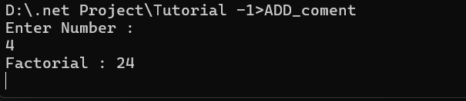

6 : Write missing statement to get the desired output.

using System;
namespace ConsoleApplication1
{
class Program
{
static void Main(string[] args)
{
int a,b,c,result;
Console.Write("Enter Number 1: ");
//Missing statement
a = Convert.ToInt32(str);

Console.Write("Enter Number 2 : ");
//Missing statement
b = Convert.ToInt32(str);

Console.Write("Enter Number 3 : ");
str = Console.ReadLine();
//Missing statement

result = Sum(a, b, c);
//Missing statement

Console.Read();
}
static int Sum(int x, int y, int z)
{
int res;
res = x+y+z;
return res;
}
}
}
Output:
Enter Number 1 : 10
Enter Number 2 : 20
Enter Number 3 : 30
Sum : 60

using System;
using System.Collections.Generic;
using System.Linq;
using System.Text;
using System.Threading.Tasks;

namespace Tutorial__1
{
internal class Missing_statement
{
static void Main(string[] args)
{
int a, b, c, result;
string str;

Console.Write("Enter Number 1: ");
str = Console.ReadLine();
a = Convert.ToInt32(str);

Console.Write("Enter Number 2: ");
str = Console.ReadLine();
b = Convert.ToInt32(str);

Console.Write("Enter Number 3: ");
str = Console.ReadLine();
c = Convert.ToInt32(str);

result = Sum(a, b, c);

Console.WriteLine("Sum = " + result);

Console.ReadKey();
}

static int Sum(int x, int y, int z)
{
int res;
res = x + y + z;
return res;
}
}
}

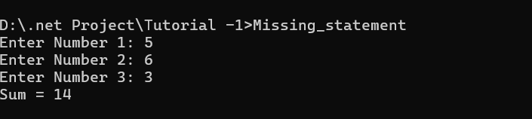

7 : Predict and write the output of the given code.
using System;

namespace While_Loop
{
Internal class Table
{
static void Main(string[] args)
{
int num1, res, i;

Console.Write("Enter a Number: ");
num1 = Convert.ToInt32(Console.ReadLine());

i = 1;

while (i <= 10)
{
res = num1 * i;
Console.WriteLine("{0} x {1} = {2}", num1, i, res);
i++;
}

Console.ReadLine();
}
}
}
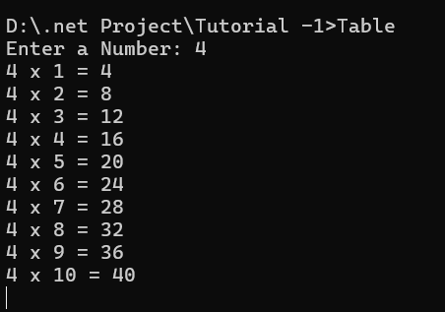

8 Write a program to convert given name in upper characters.

using System;
using System.Collections.Generic;
using System.Linq;
using System.Text;
using System.Threading.Tasks;

namespace Tutorial__1
{
internal class Upper_later
{
static void Main(string[] args)
{
Console.Write("Enter Name: ");
string name = Console.ReadLine();

string upperName = name.ToUpper();

Console.WriteLine("Output: " + upperName);

Console.ReadLine();
}

}
}

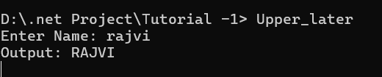

9 Write a Program to convert given name in toggle case.
INPUT : JoHn F kEnNedy
OUTPUT: jOhN f KeNneDY

using System;
using System.Collections.Generic;
using System.Linq;
using System.Text;
using System.Threading.Tasks;

namespace Tutorial__1
{
internal class ToggleCase
{
static void Main(string[] args)
{
Console.Write("Enter Name: ");
string name = Console.ReadLine();

string result = "";

foreach (char ch in name)
{
if (char.IsUpper(ch))
{
result += char.ToLower(ch);
}
else if (char.IsLower(ch))
{
result += char.ToUpper(ch);
}
else
{
result += ch;
}
}

Console.WriteLine("Output: " + result);

Console.ReadLine();
}

}
}

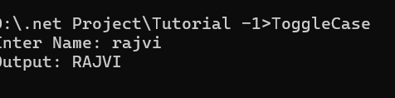

10 Write a Program which accepts mobile no as a string from the user and converts the last 5 digits into X.
INPUT : 1234567890
OUTPUT: 12345XXXXX

using System;
using System.Collections.Generic;
using System.Linq;
using System.Text;
using System.Threading.Tasks;

namespace Tutorial__1
{
internal class PHONE
{
static void Main(string[] args)
{
Console.Write("Enter Mobile Number: ");
string mobile = Console.ReadLine();

if (mobile.Length >= 5)
{
string result = mobile.Substring(0, mobile.Length - 5) + "XXXXX";
Console.WriteLine("Output: " + result);
}
else
{
Console.WriteLine("Invalid Mobile Number");
}

Console.ReadLine();

}
}
}

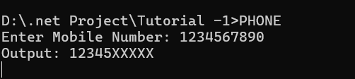

11 Write a Program which accepts name and gender from the user. Here, gender may have only 1 character, M or F.
Based on the gender prefix the name Mr. & Ms.
NAME : Hillary Clinton
GENDER : F

using System;
using System.Collections.Generic;
using System.Linq;
using System.Text;
using System.Threading.Tasks;

namespace Tutorial__1
{
internal class gen
{
static void Main(string[] args)
{

Console.Write("Enter Name: ");
string name = Console.ReadLine();

Console.Write("Enter Gender (M/F): ");
char gender = Convert.ToChar(Console.ReadLine());

if (gender == 'M' || gender == 'm')
{
Console.WriteLine("Mr. " + name);
}
else if (gender == 'F' || gender == 'f')
{
Console.WriteLine("Ms. " + name);
}
else
{
Console.WriteLine("Invalid Gender");
}

Console.ReadLine();

}
}
}

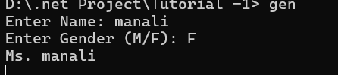

12 Write a Program which accepts name from the user and prints the same
INPUT : Winston Churchill
OUTPUT: Winston Churchill

using System;

class Program
{
static void Main()
{
Console.Write("Enter Name: ");
string name = Console.ReadLine();

Console.WriteLine("Output: " + name);

Console.ReadLine();
}
}

OUTPUT:

13 Write a Program to prints the following series
0 1 1 2 3 5 8 13 21 34 55

using System;
using System.Collections.Generic;
using System.Linq;
using System.Text;
using System.Threading.Tasks;

namespace Tutorial__1
{
internal class fibonaki
{
static void Main(string[] args)
{
int a = 0, b = 1, c;
Console.WriteLine(a + " " + b + " ");
for (int i = 2; i <= 9; i++)
{
c = a + b;
Console.WriteLine(c + " ");

a = b;
b = c;

}
}

}
}

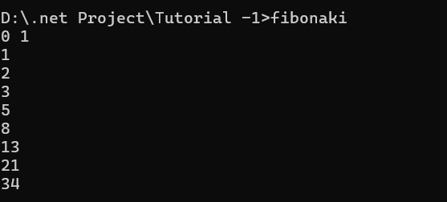

14 Write a Program which accepts no from the user and print the same in words.
INPUT : 98732
OUTPUT: Nine Eight Seven Three Two

using System;
using System.Collections.Generic;
using System.Linq;
using System.Text;
using System.Threading.Tasks;

namespace Tutorial__1
{
internal class NUMBER_STRINg
{
static void Main(string[] args)
{
//int number;
//Console.WriteLine("Enter a number: ");
//number = Convert.ToInt32(Console.ReadLine());
//string str = number.ToString();
//Console.WriteLine("The number in string format is: " + str);

String number;
Console.WriteLine("Enter a number: ");
number = Console.ReadLine();

foreach (char c in number)
{
switch (c)
{
case '0':
Console.Write("Zero");
break;
case '1':
Console.Write("One");
break;
case '2':
Console.Write("Two");
break;
case '3':
Console.Write("Three");
break;
case '4':
Console.Write("Four");
break;
case '5':
Console.Write("Five");
break;
case '6':
Console.Write("Six");
break;
case '7':
Console.Write("Seven");
break;
case '8':
Console.Write("Eight");
break;
case '9':
Console.Write("Nine");
break;
default:
Console.Write("Invalid input");
break;
}
}
}
}
}

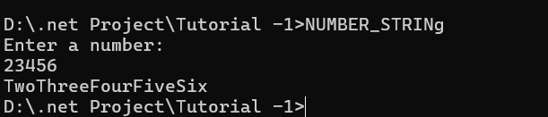

15 Write a Program to check whether the given no is Armstrong no or not.

using System;
using System.Collections.Generic;
using System.Linq;
using System.Text;
using System.Threading.Tasks;

namespace Tutorial__1
{
internal class Armstrong
{
static void Main(string[] args)
{
//int number, sum = 0, temp, remainder;
//Console.WriteLine("Enter a number: ");
//number = Convert.ToInt32(Console.ReadLine());
//temp = number;
//while (temp != 0)
//{
// remainder = temp % 10;
// sum += remainder * remainder * remainder;
// temp /= 10;
//}
//if (sum == number)
// Console.WriteLine(number + " is an Armstrong number.");
//else
// Console.WriteLine(number + " is not an Armstrong number.");

int number, original , result = 0, remainder;
Console.WriteLine("Enter a number: ");
number = Convert.ToInt32(Console.ReadLine());

original = number;
while (number = 0)
{
remainder = original % 10;
result += remainder * remainder * remainder;
original /= 10;
}
if (original == result)
{
Console.WriteLine(original + " is an Armstrong number.");
}
else
{
Console.WriteLine(original + " is not an Armstrong number.");
}
Console.ReadLine();

}
}
}

16 Write a program to display a pattern like a right angle triangle using an asterisk
The pattern like :
*
**

using System;
using System.Collections.Generic;
using System.Linq;
using System.Text;
using System.Threading.Tasks;

namespace Tutorial__1
{
internal class AEstric_pyramid
{
static void Main(string[] args)
{
int i, j, rows;
int n = 4;

for (int i = 1; i <= n; i++)
{
// Print leading spaces to center the stars
for (int j = 1; j <= n - i; j++)
{
Console.Write(" ");
}

// Print stars with a space after each
for (int k = 1; k <= i; k++)
{
Console.Write("* ");
}

// Move to the next line after finishing a row
Console.WriteLine();
}
}
}
}

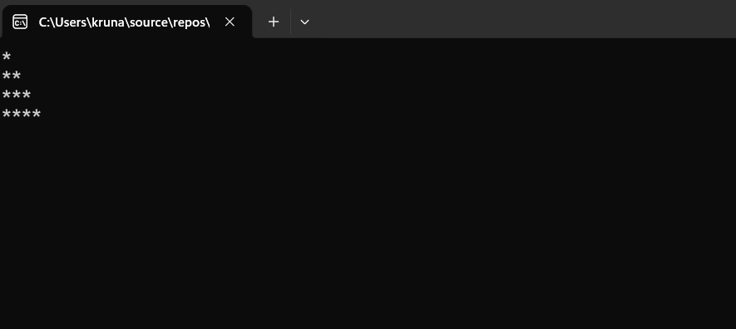

17. Write a Program to generate following output.
1
1 2
1 2 3
1 2 3 4

using System;

class Program
{
static void Main()
{
for (int i = 1; i <= 4; i++)
{
for (int j = 1; j <= i; j++)
{
Console.Write(j + " ");
}
Console.WriteLine();
}

Console.ReadLine();
}
}

OUTPUT:
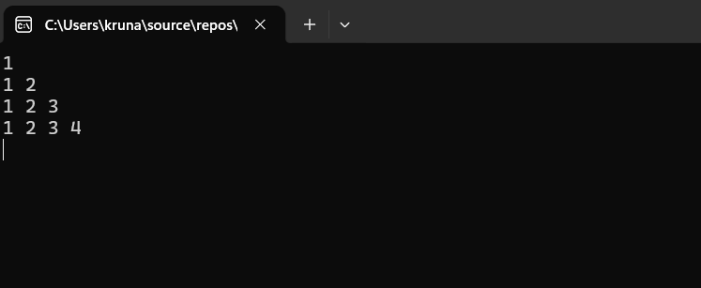

18 Write a program to make such a pattern like a right angle triangle with the number increased by 1.

The pattern like :
1
2 3
4 5 6
7 8 9 10

using System;

class Program
{
static void Main()
{
int num = 1;

for (int i = 1; i <= 4; i++)
{
for (int j = 1; j <= i; j++)
{
Console.Write(num + " ");
num++;
}
Console.WriteLine();
}

Console.ReadLine();
}
}

OUTPUT :
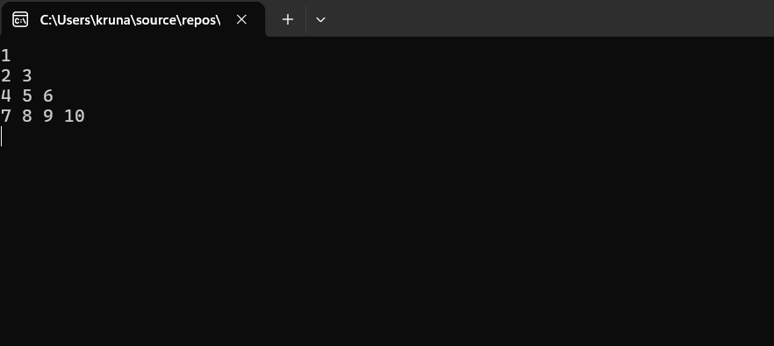

19. Write a program to make such a pattern as a pyramid with an asterisk.
*
* *
* * *
* * * *

using System;

class Program
{
static void Main()
{
int rows = 4;

for (int i = 1; i <= rows; i++)
{
// Print spaces
for (int j = 1; j <= rows - i; j++)
{
Console.Write(" ");
}

// Print stars
for (int k = 1; k <= i; k++)
{
Console.Write("* ");
}

Console.WriteLine();
}

Console.ReadLine();
}
}

OUTPUT :
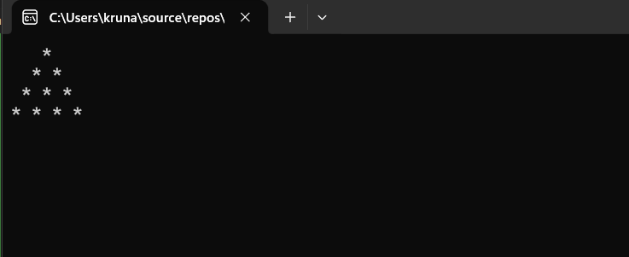

20. Write a program to make a pyramid pattern with numbers increased by 1.
1
2 3
4 5 6
7 8 9 10

using System;

class Program
{
static void Main()
{
int num = 1;
int rows = 4;

for (int i = 1; i <= rows; i++)
{
// Print spaces
for (int j = 1; j <= rows - i; j++)
{
Console.Write(" ");
}

// Print numbers
for (int k = 1; k <= i; k++)
{
Console.Write(num + " ");
num++;
}

Console.WriteLine();
}

Console.ReadLine();
}
}

OUTPUT :
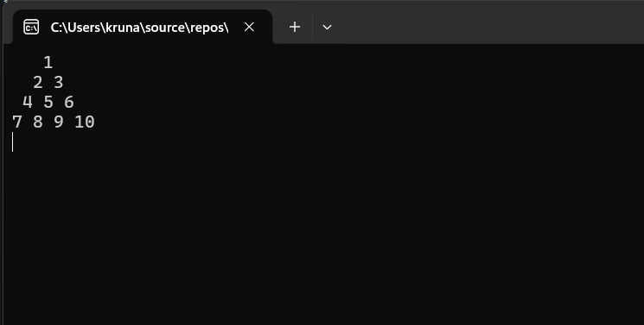

21. Write a program to find the sum of the series 5 +55 + 555 + 5555 + .. n terms.
Test Data :
Input the number of terms : 4
Input number : 5
Expected Output :
5 + 55 + 555 + 5555
The Sum is : 6170

using System;
using System.Collections.Generic;
using System.Linq;
using System.Text;
using System.Threading.Tasks;

namespace Tutorial__1
{
internal class NUMBER_SERIES
{
static void Main(string[] args)
{
int n, num;
int term = 0, sum = 0;

Console.Write("Input the number of terms: ");
n = Convert.ToInt32(Console.ReadLine());

Console.Write("Input number: ");
num = Convert.ToInt32(Console.ReadLine());

Console.WriteLine();

for (int i = 1; i <= n; i++)
{
term = term * 10 + num;
sum = sum + term;

Console.Write(term);

if (i < n)
Console.Write(" + ");
}

Console.WriteLine();
Console.WriteLine("The Sum is: " + sum);

}
}
}

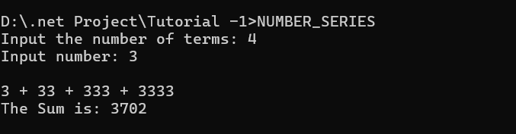

22. Write a program to display a pattern like a diamond.

using System;
using System.Collections.Generic;
using System.Linq;
using System.Text;
using System.Threading.Tasks;

namespace Tutorial__1
{
internal class DIMOND_ASTRIG
{
static void Main(string[] args)
{
int i, j, k, n;
Console.WriteLine("Enter the number of rows: ");
n = Convert.ToInt32(Console.ReadLine());
// Upper half of the diamond
for (i = 1; i <= n; i++)
{
for (j = i; j < n; j++)
{
Console.Write(" ");
}
for (k = 1; k <= (2 * i - 1); k++)
{
Console.Write("*");
}
Console.WriteLine();
}
// Lower half of the diamond
for (i = n - 1; i >= 1; i--)
{
for (j = n; j > i; j--)
{
Console.Write(" ");
}
for (k = 1; k <= (2 * i - 1); k++)
{
Console.Write("*");
}
Console.WriteLine();
}
}
}
}













